**DBMS ASSIGNMENT 5**

**CLASS: TE B**

**ROLL NO: 322008**

**Problem Statement:** Unnamed PL/SQL code block: Use of Control structure and Exception handling is mandatory. Write a PL/SQL block of code for the following requirements:-

Schema:

1. Borrower(Rollin, Name, DateofIssue, NameofBook, Status)

2. Fine(Roll_no,Date,Amt)

* Accept roll_no & name of book from user.
* Check the number of days (from date of issue), if days are between 15 to 30 then fine amount will be Rs 5per day.
* If no. of days>30, per day fine will be Rs 50 per day & for days less than 30, Rs. 5 per day.
* After submitting the book, status will change from I to R.
* If condition of fine is true, then details will be stored into fine table.

**Screenshots:**

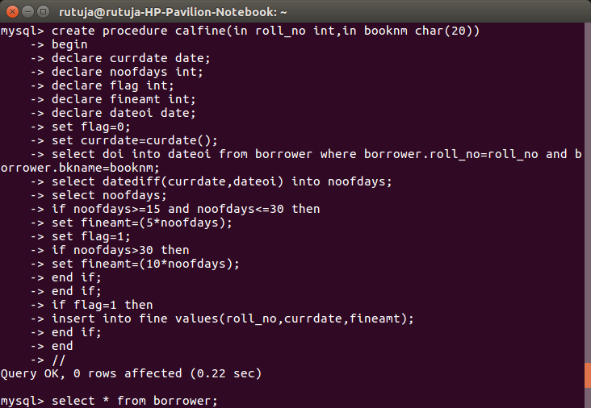

**Queries:**

Create procedure calfine(in roll_no int, in booknm, char(20))

Begin

Declare currdate date;

Declare noofdays int;

Declare flag int;

Declare fineamt int;

Declare dateoi date;

Set flag = 0;

Set currdate = curdate();

Select doi into dateoi from borrower where borrower.roll_no = roll_no and borrower.bkname = booknm;

Select datediff(currdate, dateoi) into noofdays;

Select nooddays;

If noofdays >= 15 and noofdays <= 30 then

Set fineamt = (5 * noofdays);

Set flag = 1;

If noofdays > 30 then

Set fineamt = (10 * noofdays);

End if

End if;

If flag = 1 then

Insert into fine values(roll_no,, curr_date, fineamt);

End if;

End

//

Select * from borrower;

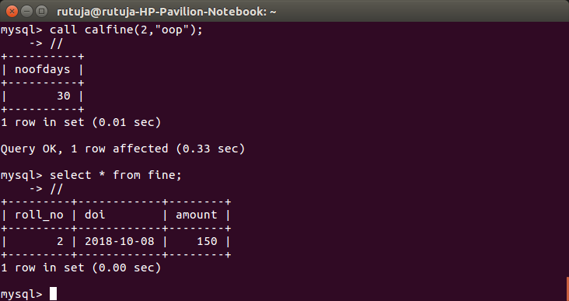

**Queries:**

Call calfine(2, “oop”);

//

Select * from fine;

//

**Conclusion:** Pl/Sql block was implemented successfully.